

**Childcare**

**Application**

**USER’S MANUAL**

*Spokane Club Childcare*

Prepared by: Blaine Abbott, Nathaniel Graham, Brian Lollis, and Brandon Fowler

June, 2015

**USER'S MANUAL**

**TABLE OF CONTENTS**

1. ***GENERAL INFORMATION***
   1. **Overview**
   2. **Acronyms and Abbreviations**
   3. **Terms**
2. ***SYSTEM SUMMARY***
   1. **System Configuration**
   2. **User Access Levels**
3. ***GETTING STARTED***
   1. **Installation**
   2. **Administrative Setup**
   3. **Picture Directory**
4. ***USING the APPLICATION***
   1. **Application** **Settings**
      1. Settings Overview
      2. Changing Settings
   2. **Parent/Guardian Reports**
      1. Loading Parent Reports
      2. Submitting Payments
      3. Saving Reports
      4. Printing Reports
   3. **Business Reports**
      1. Loading Business Reports
      2. Business Reports Examples
      3. Saving Business Reports
      4. Printing Business Reports
   4. **Adding and Editing Guardians**
      1. Adding a New Guardian
      2. Updating Guardian Information
      3. Changing Guardian Pictures
      4. Deleting a Guardian
      5. Editing a Guardian’s Children
      6. Closing the Window
   5. **Adding and Editing Children**
      1. Adding a New Child
      2. Updating Child Information
      3. Changing Child Picture
      4. Linking an Existing Child
      5. Linking A Specific Child
      6. Un-Linking a Specific Child
      7. Deleting a Child
      8. Closing the Window
   6. **Adding and Editing Events**
      1. Protected Events
      2. Event Categories
      3. Add Event
      4. Edit Event
      5. Delete Event
      6. Event Modification Window
   7. **Adding and Editing Transactions**
      1. Editing Transactions
      2. Deleting Transactions
      3. New Transactions
      4. Transaction Modification Window
   8. **Checking Children In and Out**
      1. Checking a Child In or Out as a Guardian
      2. Checking a Child In or Out as an Administrator
5. ***BACKUP and RESTORE***
   1. **Automatic Backup System and Restore Points**
   2. **Complete Re-Installation**
6. ***TROUBLESHOOTING***
   1. **What to do if Something Goes Wrong**

# 

# 1.0 General Information

## 1.1 Overview

This application was designed by senior students in the Eastern Washington University Computer Science Department. It provides a system through which parents/guardians may check children in or out of the Spokane Club Childcare Center and provides detailed information of transactions. This application also provides many administrative tools that include: automatic billing calculations, guardian balance management, generation of billing reports for both guardians and Spokane Club employees, custom childcare events, and more. The overall goal of this application, is to ease and expedite the process through which childcare transactions are made, recorded, and organized. This user manual will provided detailed instructions for the use of this application, and all included tools.

## 1.2 Acronyms and Abbreviations

PC - Personal Computer

## 1.3 Terms

Family - A relation between one or more parent/guardian and children, that share the same billing account and balance.

Guardian - A parent/legal guardian, or trusted caretaker of a child. The words “parent” and “guardian” are used interchangeably in this document and in the application.

## 

# 

# 

# 2.0 System Summary

## 2.1 System Configuration

This application is designed to be used with Windows 7, Windows 8, or Windows 8.1. It also requires .NET Framework version 4.5, which can be acquired through standard Windows Updates or downloaded for free at www.microsoft.com. This software is designed for use on a desktop or laptop PC, and is not tested for compatibility with tablets or any other mobile or computing device.

## 2.2 User Access Levels

This application is designed to be accessed by two types of users. The child check-in system will be accessible by parents/guardians, who will be allowed to login with their own credentials, then check their registered children in or out of the system. Administrators are the second type of user, and have sublevel designations that determine their level of access. These sublevels are:

* Super User
* Full Access
* Limited Access

A Super User has only one function, the ability to add new administrators or delete existing administrators. Full Access administrators, can access every part of the application, and fully manipulate all settings, records or customization options. Limited Access users can access the parts of the application that allow children and guardians to be modified.

# 3.0 Getting Started

## 3.1 Installation

To begin installation of this application, simply run the provided installer called “setup.exe”. Follow the on-screen instructions that guide the installation process. When prompted to choose an installation path, the default path is recommended. However, should an alternate installation path be desired, the option to browse to a new installation location is provided via the “Change” button. After choosing an installation path, continue following the on-screen instructions, until the installation is finished. Once finished, a shortcut will be placed on the desktop and in the start menu; and the application will be ready to launch from either location.

## 

## 

## 

## 

## 

## 

## 

## 

## 

## 

## 

## 

## 3.2 Administrative Setup

### 3.2.1 Creating Your First Administrator

*See accompanying documentation on first user setup.*

### 

### 3.2.2 Editing Your Administrator

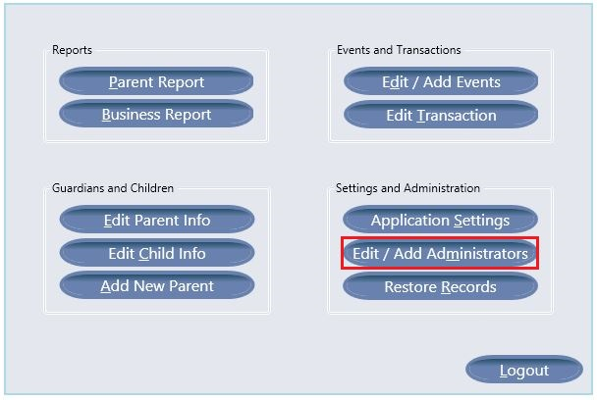

Select “Edit/Add Administrators” from the menu option. This will bring up the window for administrator maintenance.

Select the administrator you wish to edit from the list on the left. This will fill the form with the information for the selected administrator.

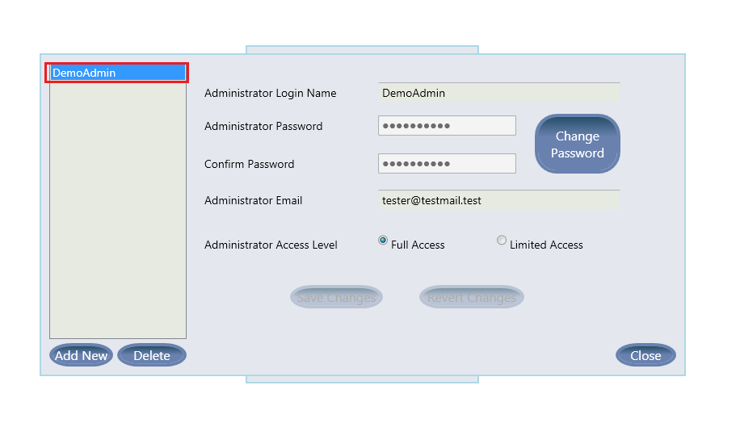

Once on this window you can edit the various fields to change your information.

Edit your login name Edit your email

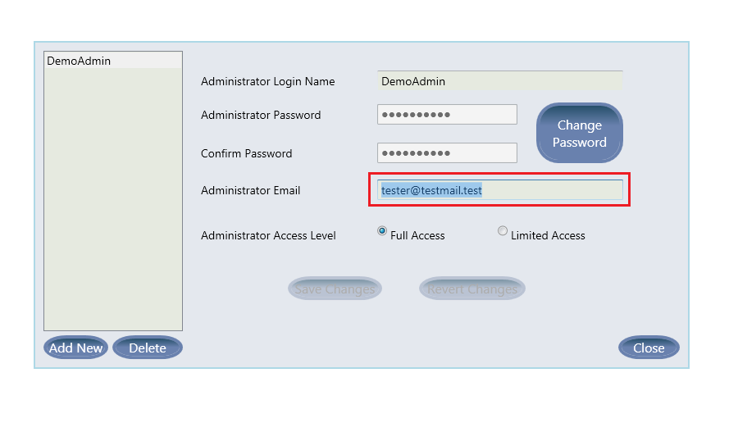

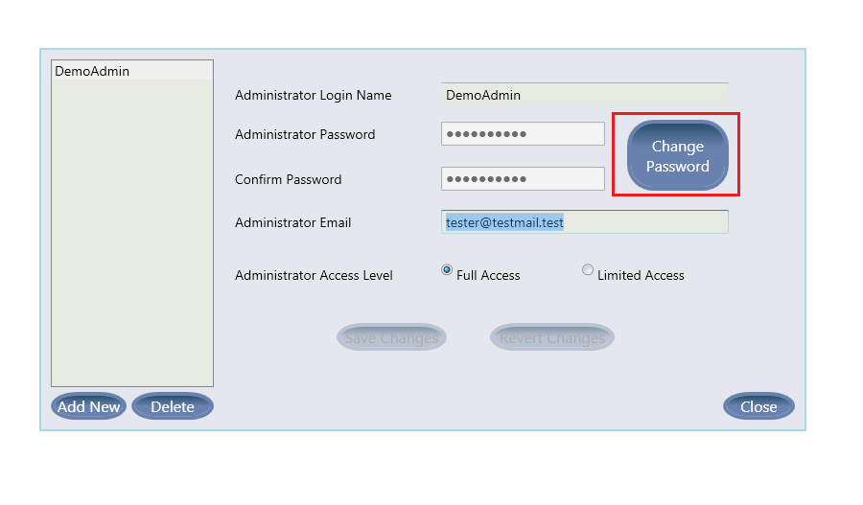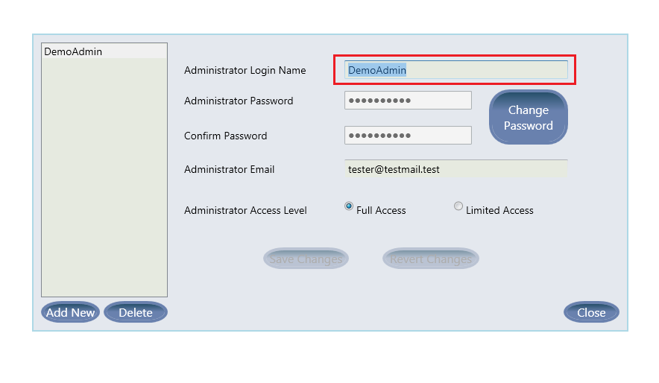

Change your password

Make sure passwords match Confirm password change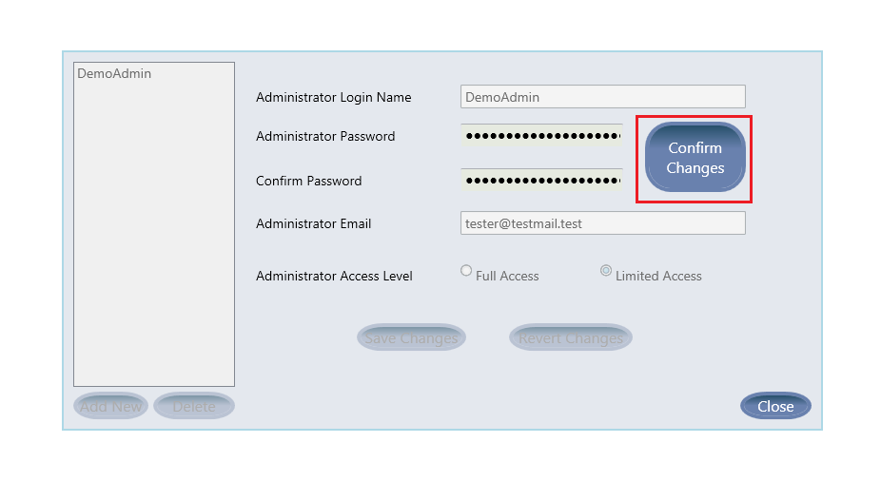

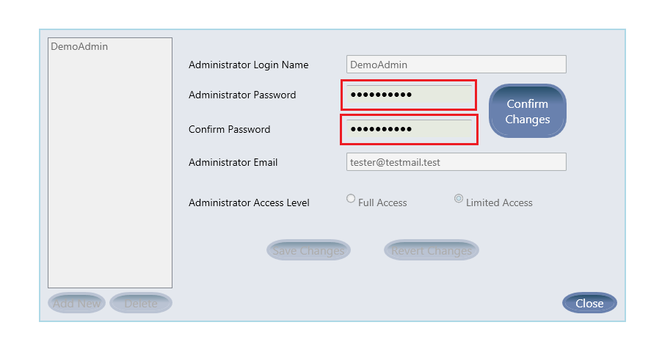

Change access level. **Note**: if you are logged in as an administrator with Full Access privileges you will not be able to lower your access level to Limited access. You must be logged in to a different administrator account to make this change.

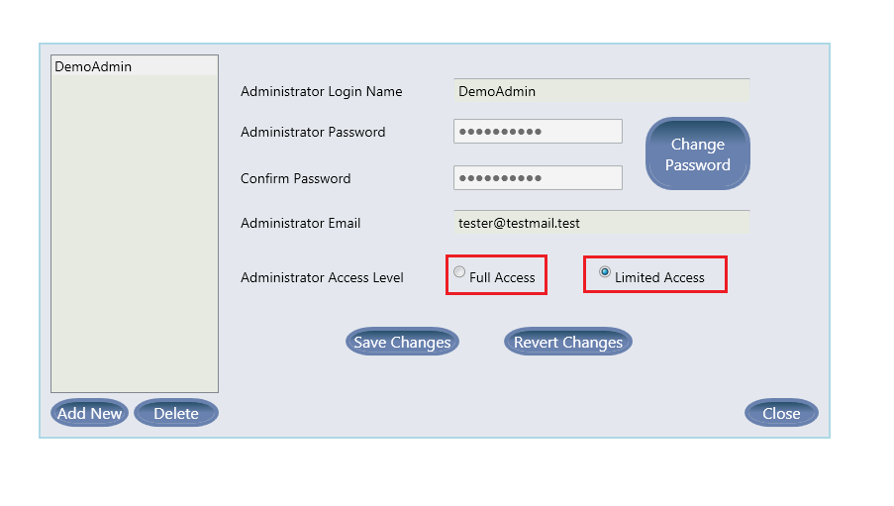

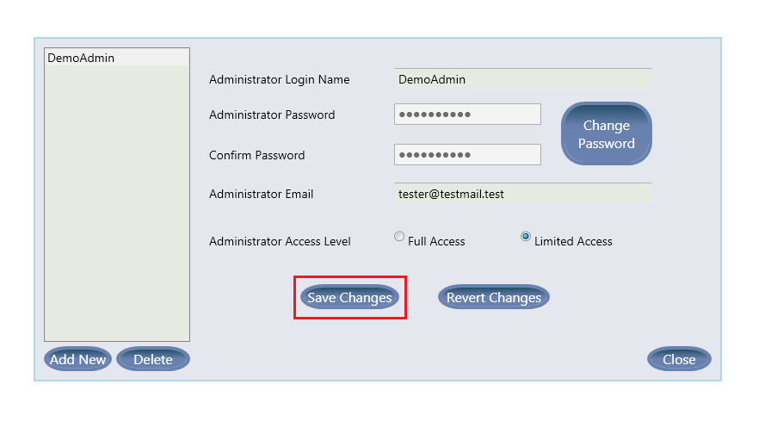

**Save your changes**. If you do not save your changes before selecting another administrator or closing the window then the changes will be discarded.

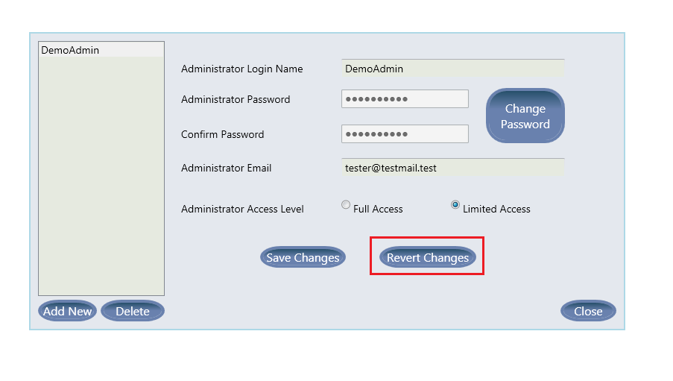

**Revert your changes** to the administrator account without saving changes.

### 3.2.3 Creating Additional Administrators

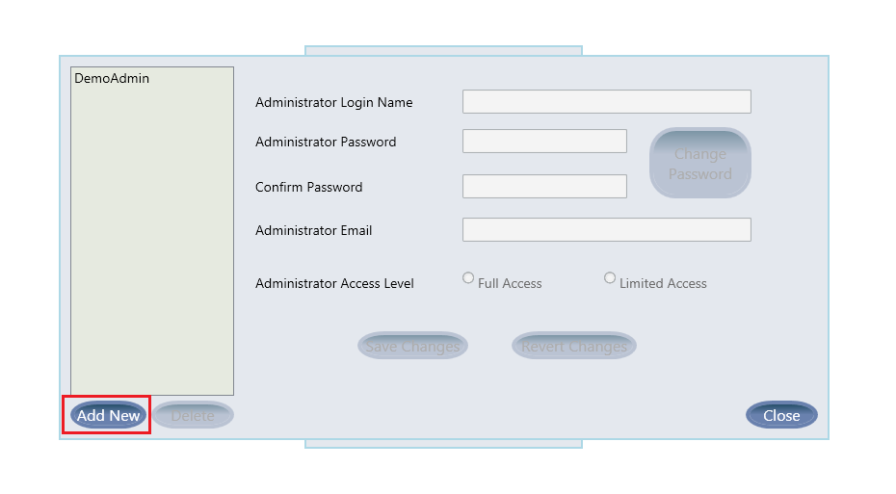Click the Add New button below the list of administrators on the left. This will create a new administrator with the default values.

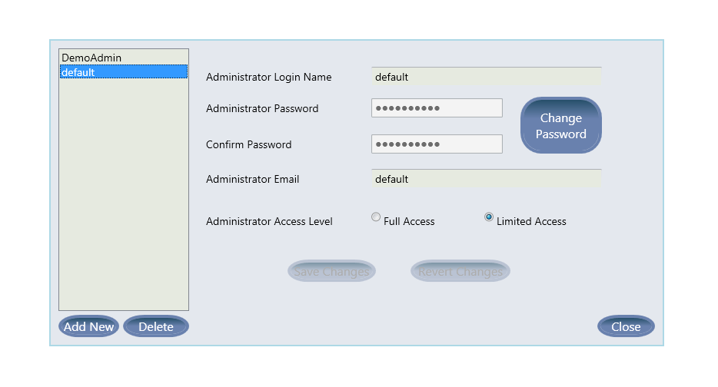You must go through the steps in section 3.3.2 to edit the default administrator before the new administrator will be useful to the application. Be sure to set up a Login Name, Change your Password, Set the correct access level, and most importantly remember to Save your Changes before continuing. These values can be changed at any time by visiting this window.

### 3.2.4 Deleting Administrators

Select the Delete option to delete the currently selected administrator from the list.

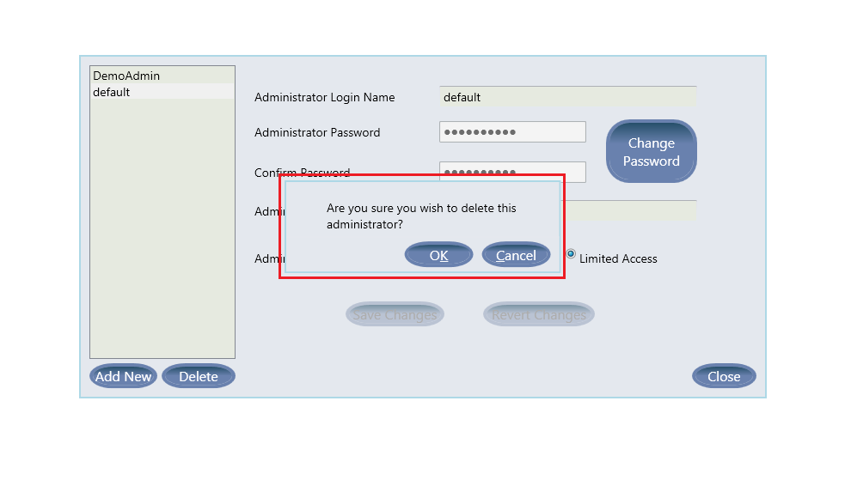

This will bring up a confirmation dialog to confirm that the administrator you have selected is the one you wish to delete, as this process is not reversible.

The selected administrator will be removed from the system.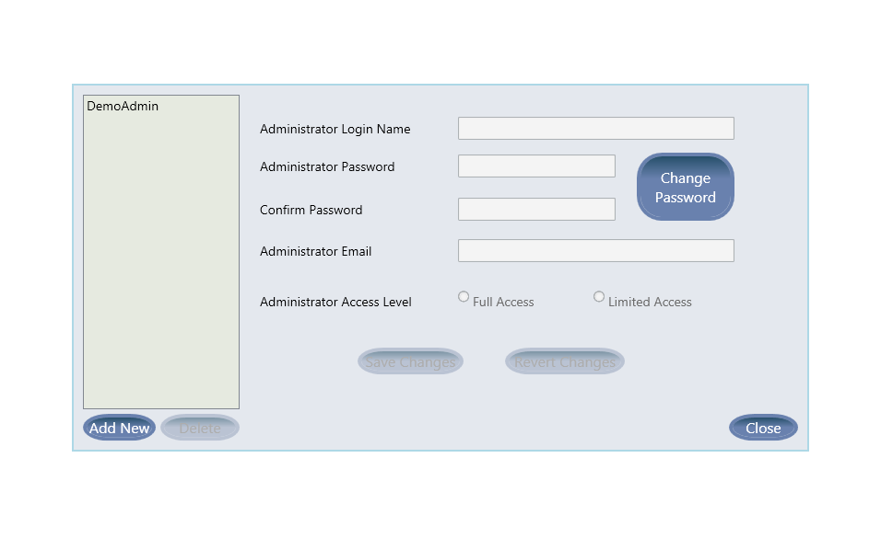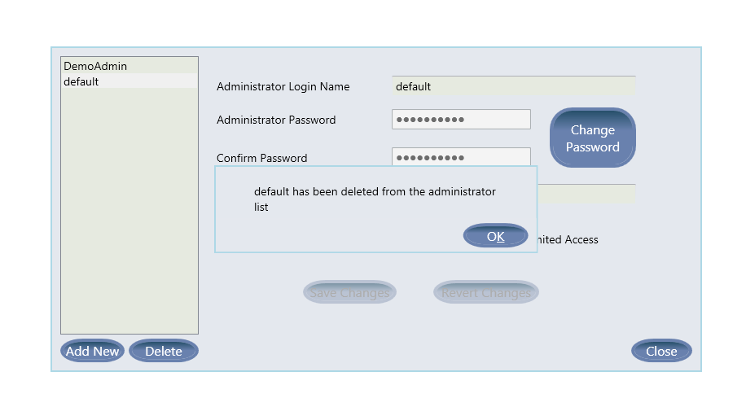

## 3.3 Picture Directory

The picture folder, is where all images that will be used by the application must be placed. By default, the picture directory is within: C:\Users\Public\Documents\Childcare Application. Within this directory, multiple folders will be visible. Open the picture directory, then place all pictures that will be used by this application.

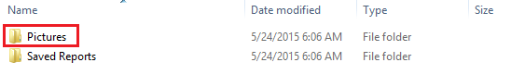

# 

# 

# 

# 

# 

# 

# 

# 

# 

# 

# 

# 

# 

# 4.0 Using the Application

## 4.1 Application Settings

There are several settings which the application uses to ensure a fully customizable experience for the user. A brief overview of each setting and its purpose will be listed here:

* *Start of Billing Cycle:* The day of the month that will start your billing cycle. The billing cycle will end on the day previous to the start day. For instance, if the start of your billing cycle is on the 15th, the ending day will be the 14th of the following month.
* *Maximum Monthly Charge for Regular Childcare:* This is the maximum amount a family will be charged in a single billing cycle for regular childcare.
* *Number of Days to Hold Expired Records:* When a child, guardian, connection, administrator, or event is deleted. Those records are stored in the database for a certain amount of time for record keeping purposes. Once the number of days stored in this setting have passed, the deleted records are purged from the database.
* *Infant Age End:* Stored as years, this is the age when “infant” childcare ends. Children over this age are processed under the “regular” childcare pricing structure.
* *Regular Age End:* Stored as years, this is the age when “regular” childcare ends. Children over this age are processed under the adolescent pricing structure.
* *Default Report Folder:* This is the folder that reports will be saved to by default.

There are also settings for each day of the week:

* *Closed*: A checkbox. When checked, the opening and closing times for the associated day are disabled.
* *Opening*: The time of day the business opens.
* *Closing*: The time of day the business closes.

A note on how to enter the time you want: The application has been designed to accept a large variety of times entered in various ways, but for utmost clarity it is recommended to enter the time of day in the following format: HH:mm based on a 24-hour clock. This will ensure that even if the am/pm designation is forgotten you will still have the correct time of day recorded into your settings.

### 4.1.1 Changing Settings

Select the setting you wish to change by clicking on it within the window

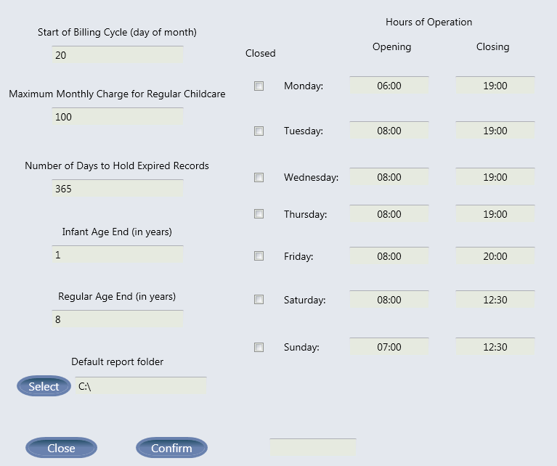

## 

## 4.2 Parent/Guardian Reports

Parent reports provide billing data for specific parents/guardians and can be accessed by clicking the “Parent Report” Button. Parent reports are intended to keep track of parent/guardian balances and provide information related to a specific parent/guardian. Parent Reports display each individual transaction for a specific parent/guardian. These reports could be printed and given to a parent/guardian if they had questions about their bill.

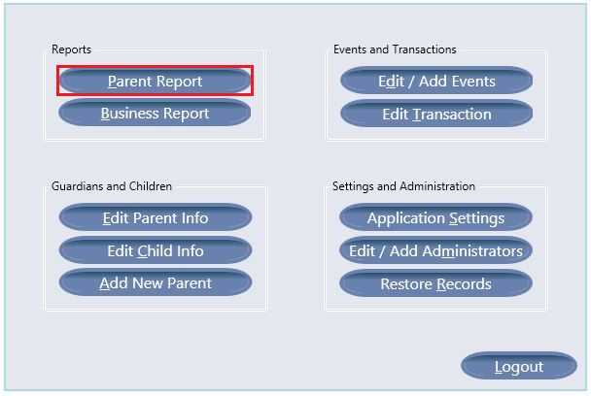

### 4.2.1 Loading Parent Reports

To load a report for a specific parent/guardian enter their ID number in the Guardian ID text box, and click the “Load All Charges” button, the “Current Billing Cycle” button, or the “Date Range Report” button. The “Load All Charges” button will load all charges currently in the database for the entered Guardian ID. The “Current Billing Cycle” button will load all charges for the current billing cycle associated with the specified guardian. The “Date Range Report” button will load all charges associated with the specified guardian ID for the specified date range.

### 4.2.2 Date Range Reports

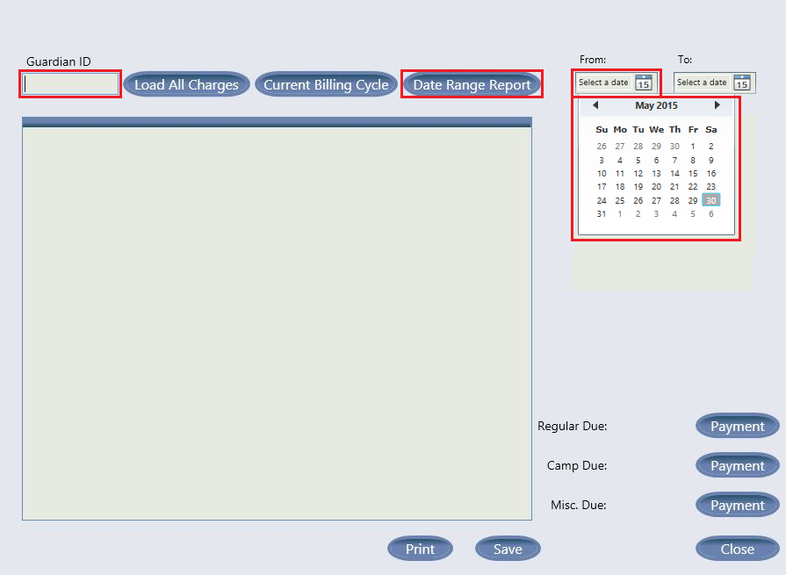

To create a date range report, use the two datepickers to select a from and to date. You may either manually enter a date in the text box, or click the calendar icon to select a date. Once both dates are picked, you may click the “Date Range Report”.

### 

### 

### 

### 4.2.3 Submitting Payments

To submit a payment for the currently loaded report, click the “Payment” button associated with the balance you would like to submit a payment against.

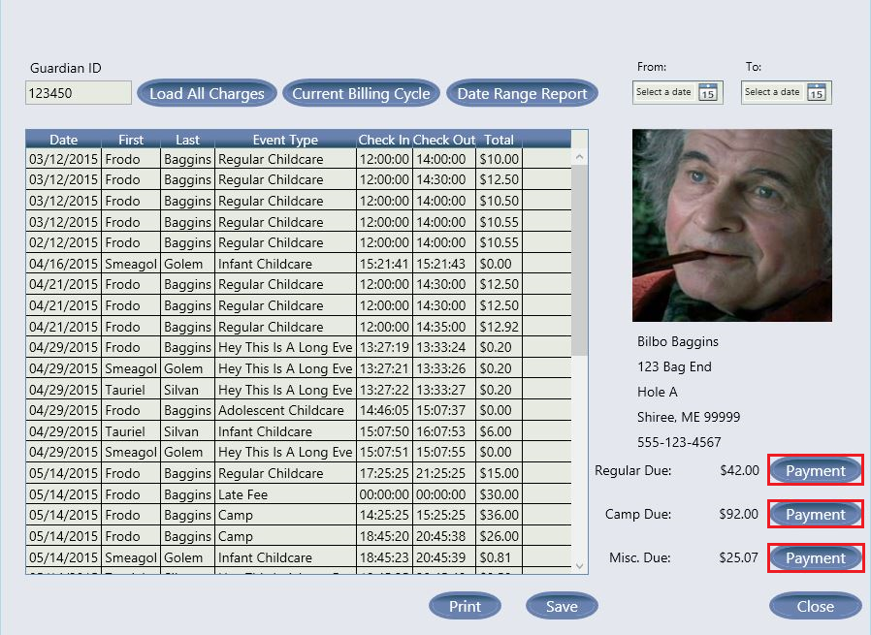

## 

### 4.2.3.1 Payment Entry

After clicking the Payment button, a new window will open which you can use to enter the amount of the payment. The current balance for the balance category associated with the payment button you clicked will be displayed in the payment window. You may then enter a dollar value in the Payment Amount text box. Click “Submit Payment” to submit the payment, or “Cancel” to abort the submit payment process.

## 

### 4.2.4 Saving Reports

Reports can be saved as PDFs. To accomplish this, click the “Save” button.

### 

### 

### 

### 4.2.4.1 Save Dialog

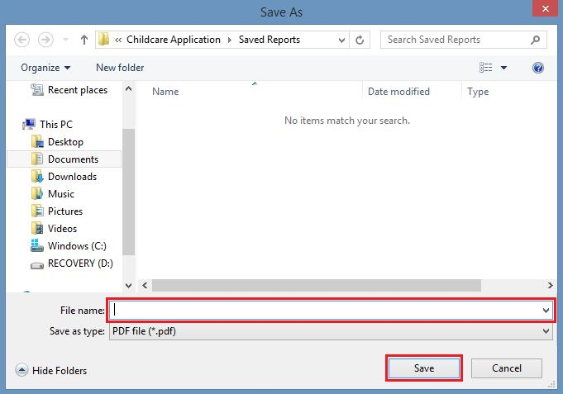

After clicking the save button, a save dialog will open to facilitate saving the report. The save dialog will open in the directory specified by the Default Report Folder setting, but you may save reports wherever you like. Enter a filename in the File Name text box and click “Save”. This will save the report in the directory specified.

### 

### 

### 4.2.5 Printing Reports

Reports can be printed as PDFs. To accomplish this, click the “Print” button.

### 

### 

### 

### 

### 

### 

### 4.2.5.1 Print Dialog

After clicking the print button, a print dialog will open to facilitate printing the report. Select the printer you wish to use and click “Print”.

## 

## 

## 

## 4.3 Business Reports

Business reports provide transaction data for all parents/guardians and can be accessed by clicking the “Business Report” button. Business reports are intended to be used for billing purposes and to provide an overview of what transactions have occurred in a given billing cycle. In the business reports, all transactions of the same type are summed and grouped by guardian ID. If two transactions of the same type are charged to two different parents/guardians in the same family, the charges will be added together and associated with the lowest numerical guardian ID in the family. The balances for regular childcare and camp events are displayed next to the first event in the associated category for each family. For clarification, see the example in 4.3.2.

## 4.3.1 Loading Business Reports

To load a Business Report, you can click the “Current Month Report” button, or the “Specific Month Report” button. The Current Month Report will load all charges for the current billing cycle (the start date for the billing cycle is set in the Application Settings window). To load a report for a specific month, select the month and year in which the billing cycle you are interested in starts, and click the “Specific Month Report” button.

### 

### 

### 

### 4.3.2 Business Reports Examples

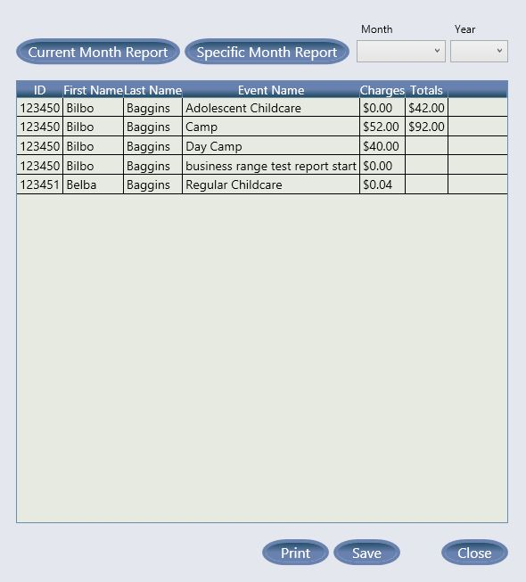

In the following example only transactions for the Baggins family have been charged. Adolescent Childcare is free in this example, but since it is the first event of the regular childcare category, the total balance for that category is displayed next to it Some charges carried over from the previous billing cycle, so the total is higher than charges shown for this billing cycle. Similarly, Camp is the first event in the camp category, so the camp category total balance is displayed next to it. Belba Baggins is the only parent/guardian in the Baggins family to have Regular Childcare charges, so her name and ID are shown for the Regular Childcare charges. In this example, there were actually two charges for Day Camp. There was one charge that was billed to Belba Baggins for $20 and another that was charged to Bilbo Baggins for $20. Since Belba and Bilbo are in the same family and Bilbo has the lowest ID, only Bilbo is shown in this report. The event named “business range test report start” is considered a miscellaneous event and events in the miscellaneous event category do not have the miscellaneous event total displayed next to them.

### 4.3.3 Saving Business Reports

Reports can be saved as PDFs. To accomplish this, click the “Save” button.

### 

### 

### 

### 

### 

### 

### 

### 

### 

### 4.3.3.1 Save Dialog

After clicking the save button, a save dialog will open to facilitate saving the report. The save dialog will open in the directory specified by the Default Report Folder setting, but you may save reports wherever you like. Enter a filename in the File Name text box and click “Save”. This will save the report in the directory specified.

### 4.3.4 Printing Business Reports

Reports can be printed as PDFs. To accomplish this, click the “Print” button.

### 

### 

### 

### 

### 

### 4.3.4.1 Print Dialog

After clicking the print button, a print dialog will open to facilitate printing the report. Select the printer you wish to use and click “Print”.

## 

## 

## 

## 4.4 Adding and Editing Guardians

### 4.4.1 Adding a new Guardian

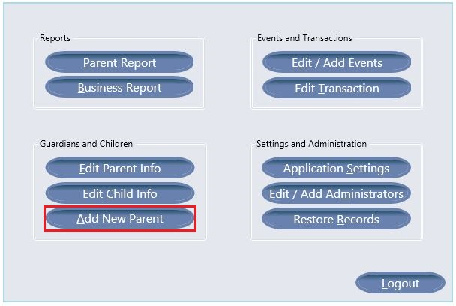

Adding a new guardian to the database will allow administrators to create an account for those guardians and to be able to edit their information. This will also allow the added guardian the functionality of checking their children in and out with the application. The first step in adding a new guardian is to login as an administrator. After that, you are presented with the administrator menu. From the administrator menu, you will click the “Add New Parent” button. This button will take you to the window for adding a new guardian.

* 3. 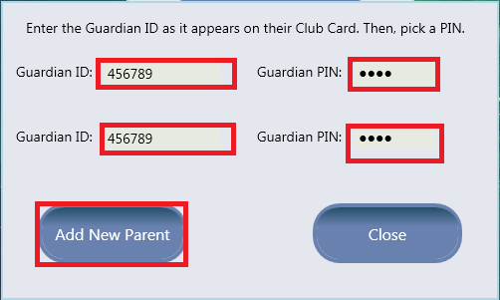
  4. The next window you will see is the window to create the Guardian ID and PIN number. The Guardian ID number is from the Spokane Club member card. It is very important that the guardian enter the ID number just as it appears on their Spokane Club member card. The guardian will then enter a PIN number for themselves. The PIN number is only used by the guardian when logging into the system. It is very important that the guardian remembers his/her PIN. Finally, of course, you will want to click the “Add New Parent” button here to finalize this action. The window to edit a guardian’s information will display automatically after successfully creating a new guardian.

### 4.4.2 Updating Guardian Information

* + - 1. 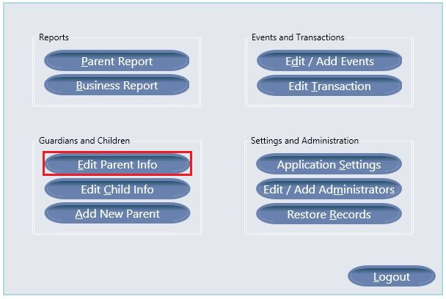

To edit a guardian’s information you will need to click the “Edit Parent Info” button found on the Administrator Menu. From here you will be presented with another window. In this window, you will need to enter the ID number of the guardian whose information you wish to edit. After you enter the ID number, click the “Submit” button to continue.

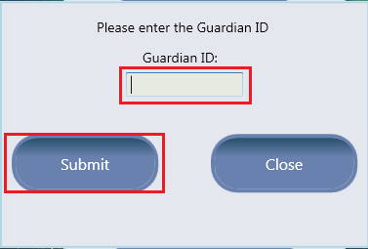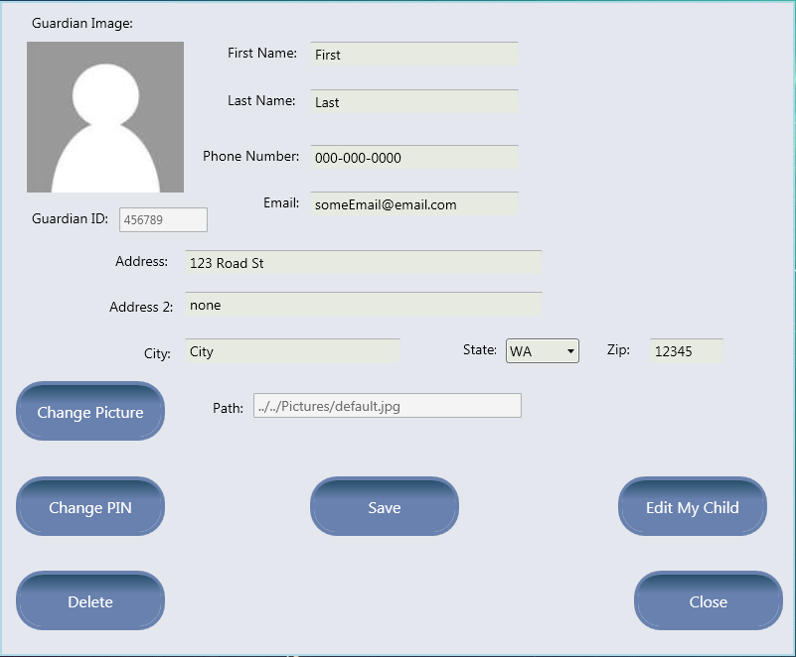

Once you have completed these steps, you will now be able to edit any guardian’s information. This form will be filled with default information when adding a new guardian.

From this page you will be able to edit any of the guardian’s information. You do this by simply filling out the form with new, correct information. Do not forget to click the “Save” button or the changes will not be saved to the database.

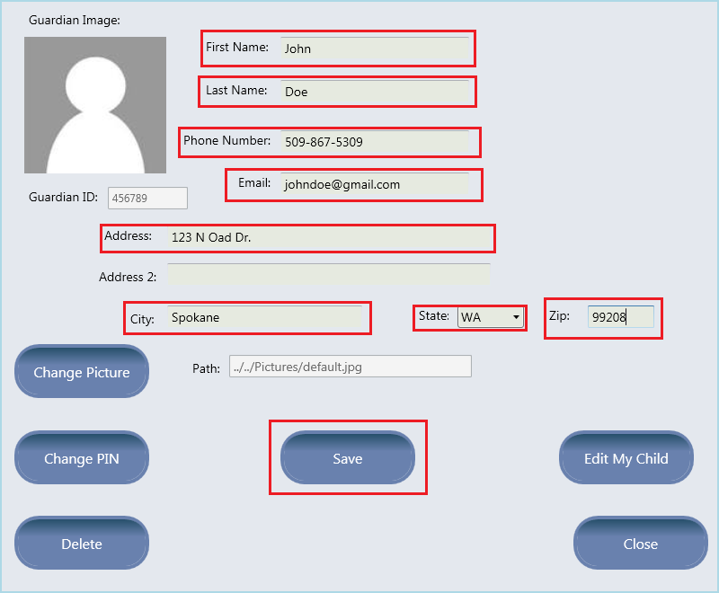

The areas boxed in red indicate an area of the form that must be filled out.

Upon filling out this form correctly, you will see this message box after clicking the “Save” button.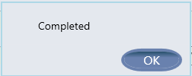

### 

### 4.4.3 Changing Guardian Pictures

In order to change a guardian’s picture, you will begin by clicking the “Change Picture” button on the window. Once the button is clicked you will see a file browser pop up. The directory that comes up by default is where all pictures of guardians and children should be stored. **The images in this folder must be in a .jpg file format.** You will not be able to update a guardian's image to anything other than a .jpg file.

* + 1. - 1. After you click the “Change Picture” button you will see this file browser. Click on the image you want to use as the guardian’s image. 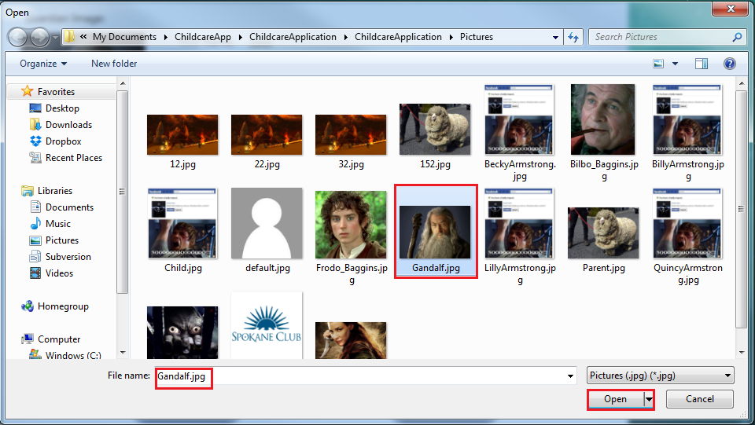

You can set this as the image for the guardian by either double clicking the image or clicking the “Open” button in the bottom right corner.

After an image is chosen, you will be sent back to the main window for editing guardian information. Do not forget to click save or, just as before, you will not save this image change to the database.

#### Please take note that every image in the folder is a .jpg file.

### 4.4.4 Changing Guardian PIN

* + - 1. If a guardian has forgotten their PIN number they will not be able to log into the Guardian side of the application. Administrators, from the Edit Guardian window, can permanently change a guardian’s PIN number. Do not do this without the guardian’s consent. Please try to remind them to remember their PIN number, this change should only be used if you absolutely must change a guardian’s PIN.
         1. After you click the “Change PIN” button, you will be prompted with a new window to confirm you wish to change this specific guardian’s PIN. If you click the yes button, you will continue to the next window where you will enter a new PIN for the guardian.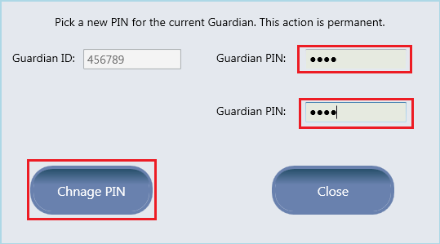

From here you will need to enter a new PIN number for the guardian. Once you have entered the new PIN, click the “Change PIN” button to save this PIN to the database.

#### 

#### 

#### 

#### 

#### 

#### 

#### This change is final and there is no way to get the PIN back once it is changed. Please do not lose your PIN.

### 4.4.5 Deleting a Guardian

* + - * 1. 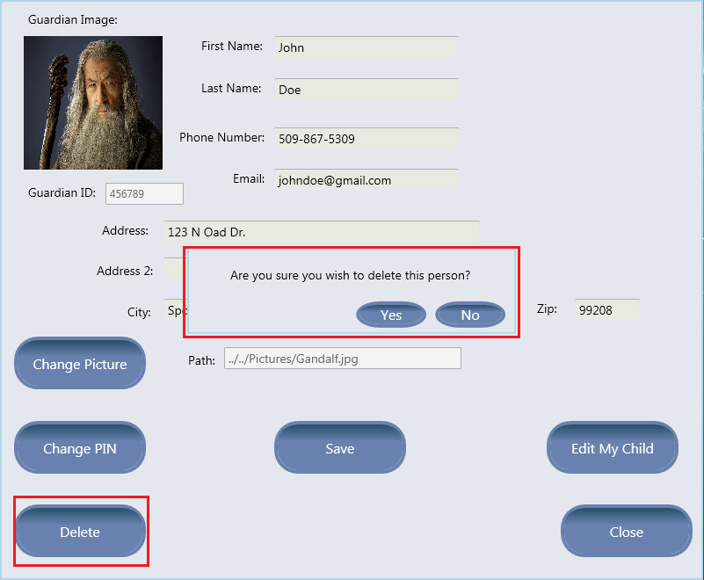

When desired, you will be able to delete a guardian. The guardian will stay in the database up to one year for billing purposes. Once you delete a guardian, you will not be able to log in as that guardian, edit that guardian’s information, or created a guardian with the same ID as the one you have deleted.

* 1. 1. To delete a guardian, click the Delete button in the bottom left corner of the window. You will be prompted with a deletion confirmation, asking if you are positive you wish to delete this guardian. Clicking “yes” here will delete the guardian. Clicking”no” will cancel the action.

#### This action is final and there is no way to undo this deletion.

### 

### 

### 4.4.6 Editing a Guardian’s Children

* + - * 1. From the edit guardian window, you can take a shortcut to editing this guardian’s children. The next section, 4.5, will go over this in great detail. To do this, click the “Edit My Child” button found on the bottom right part of the window.

### 

### 

### 4.4.7 Closing the Window

Once you have finished editing the guardian’s information, you will want to return to the administrator menu to continue work in other areas. If you have finished working here, click the “Close” button to go back the the Administrator Menu.

**Closing the window does not automatically save any changes you have made.** In order to save changes, make sure you have clicked the “Save” button before closing the window.

## 

## 4.5 Adding and Editing Children

* + - 1. 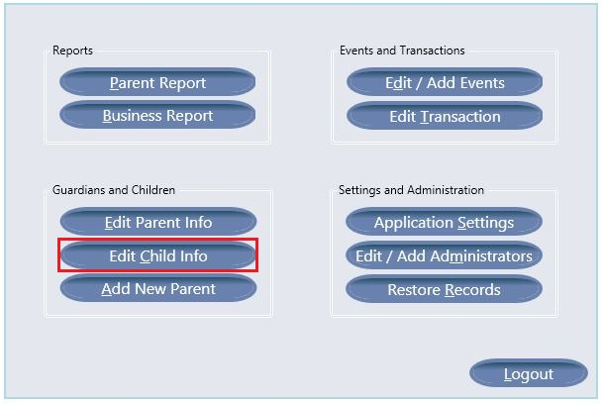

Adding a new child to a Guardian will allow the Guardian to check the child in and out using the Guardian side of the application. The administrator will also be able to edit the child’s information so long as the administrator has access to the guardian’s Spokane Club ID number.

The first step to adding and editing child information is to open the Administrator Menu. Once here you will want to click the “Edit Child Info” button.



Once you have clicked this button, you will be prompted to enter the Guardian ID of the guardian this child belongs to. After you have entered the ID number, you will click the submit button. Providing the Guardian ID entered is a valid ID currently in the application, you will continue to the next window for adding and editing children.



To do this from the “Administrator Edit Parent Window” refer to section 4.4.6.

### 

### 4.5.1 Adding a new Child

If you are adding a child to a guardian with no children, you will need to first add a child to the guardian. This is done by clicking the “Add New Child” button in the middle left of the window. This will add a child to this guardian and this guardian only.

Once you have done this, a default child is added to the guardian. You may then enter correct information for the child and save it to the database. You can add as many children to a guardian as you need to.

* 1. 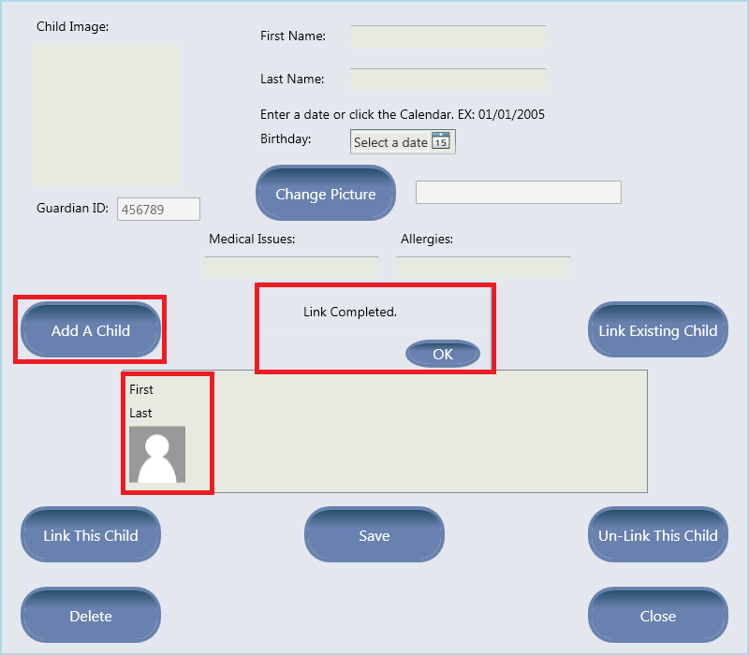

### 

### 4.5.2 Updating Child Information



In order to update a child’s information, you must first select a child from the child list box displayed in the window. Once that child is selected, the text boxes will fill with that child’s information. This information can be edited and then saved. 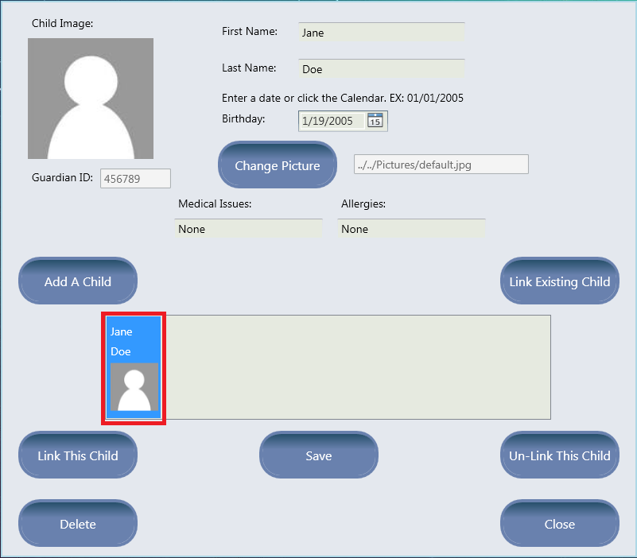

To finalize an update to a child’s information, you must click the “Save” button in the bottom middle of the window. This button saves the information to the database. If you close this window without clicking this button, no changes will be saved.



Upon completing the form and clicking save, you will see a message box confirmation that your changes have been saved. 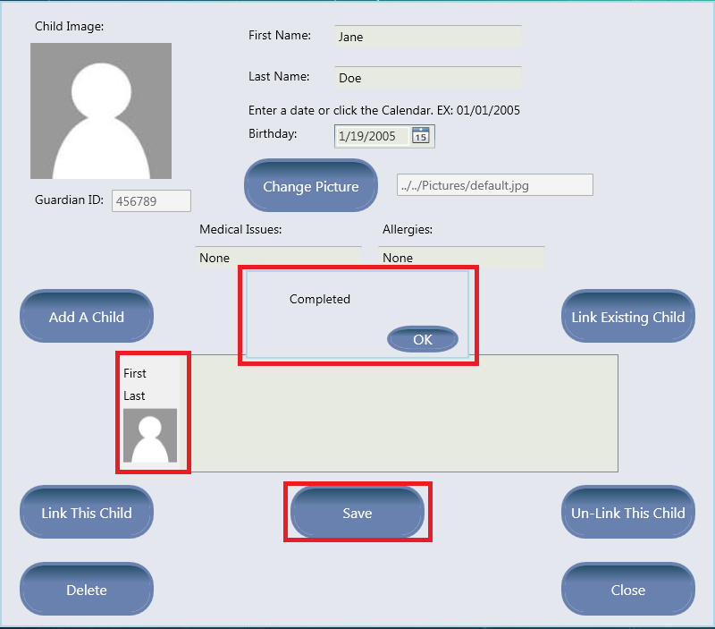



### 4.5.3 Changing Child Picture



If you wish to change the picture of a child, you must first select the child in the Child Selection Box. The next step is to click the “Change Picture” button found in the top middle part of the form.

* 1. 1. From here, you will see a file browser. This will open to the correct directory where pictures must be stored for the application.

#### Pictures must be in a .jpg format.

* + 1. If the picture you try to use as the child image is not a .jpg, the application will reject the command. Once you select the picture, either double click it, or click the “Open” button in the bottom right part of the window. 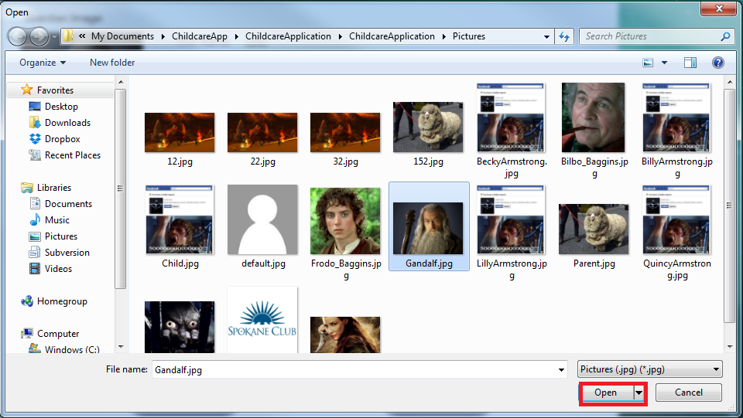

Once you have selected the picture, you will want to save the changes. Selecting a picture does not automatically save it to the database. As a final step, you must click the “Save” button in the bottom middle of the window. This will finalize the picture change.

* 3. 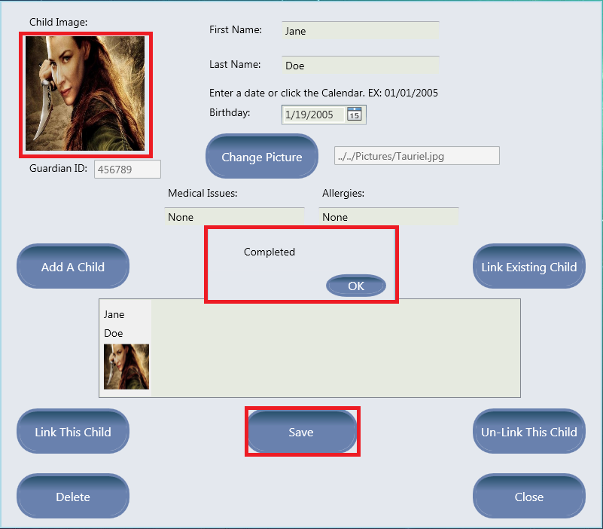

### 4.5.4 Linking an Existing Child



Linking an existing child is a helpful way to quickly link children in the same family to different guardians also in the same family. Spokane Club Member Id’s are set up in a way where the first five digits of the six digit ID number are the same. The last digit is different. An example of this would be: Guardian 1 ID: 123450, Guardian 2 ID: 123451. 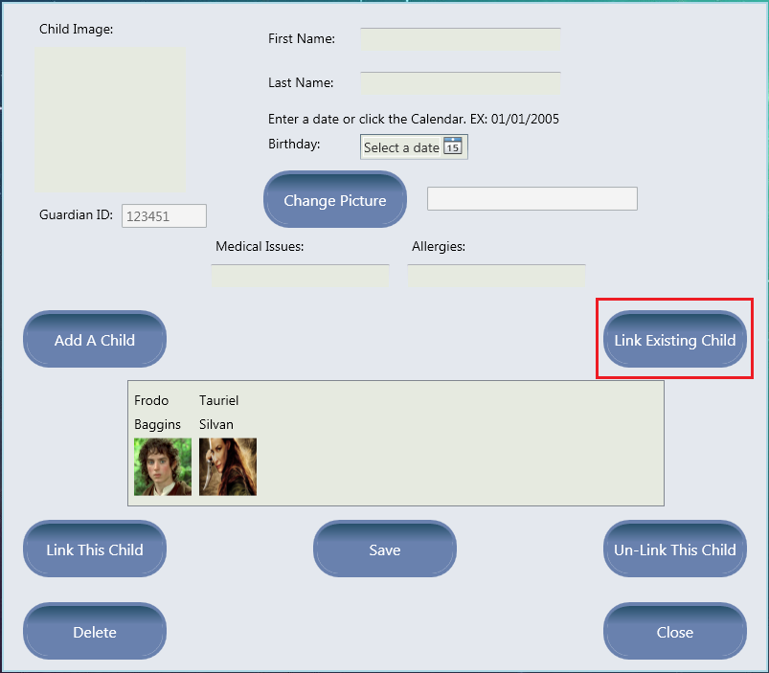



If one guardian in the same family already has a child added to themselves, you do not want to re-create the same child for a different parent. What you can do is click the “Link Existing Child” button in the middle right side of the window. 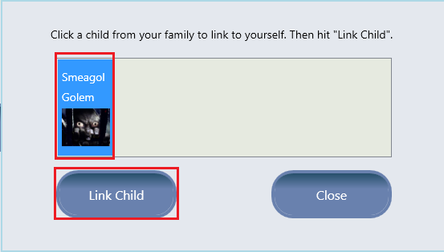

This will bring up a window that shows all the children who are in the same family, based on Guardian ID number, who are **NOT** currently linked to the current guardian logged in. From this window, you can select any of those children and link them to this guardian. 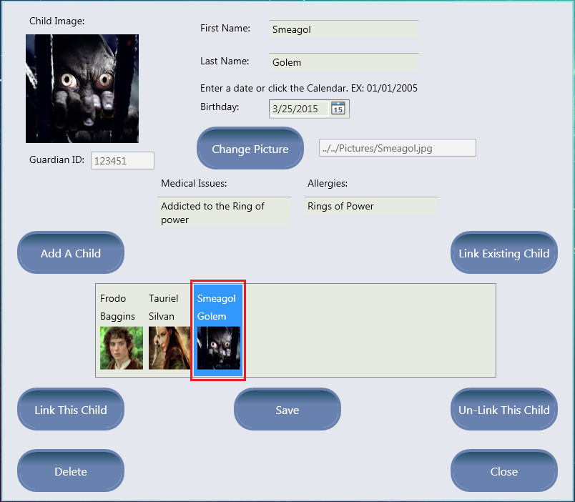

This will allow that guardian to be able to check the child in and out on the Guardian side of the application. The administrator will also be able to edit that child’s information using any of the Guardian ID numbers that the child is linked to.

### 

### 

### 4.5.5 Linking A Specific Child



If the guardian knows they want to link a child to another guardian, then using the “Link This Child” button is the best way. This button allows the administrator to enter a new guardian ID for the child to be linked to. This means that the new guardian will have full access to this child for checking in and out with the guardian side of the application. The new guardian ID can also be entered when you click “Edit Child Info” from the Administrator Menu.

If you wish to link a child to a different guardian, the first step is to select a child in the child selection box. This indicates what child you wish to link to another guardian. Then you will click the “Link This Child” button. From here, you will be presented with a small window. 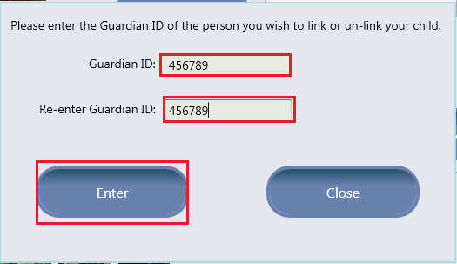



In this new window, you will want to enter the guardian ID of the guardian you wish to have access to the selected child. After you enter the guardian ID, click the “Enter” button. This will then link the child to the guardian.

* 2. 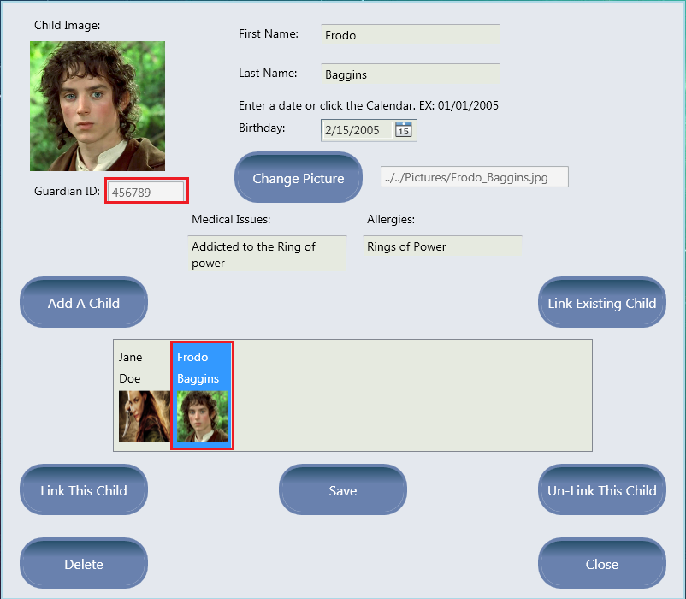

As you can see here, the guardian ID we entered above was “456789”. If we go to edit that guardians children, Frodo is now on their child box selection list. This guardian has full access to this child’s information and can check the child in and out using the guardian side of the application.

### 4.5.6 Un-Linking a Specific Child

* 1. 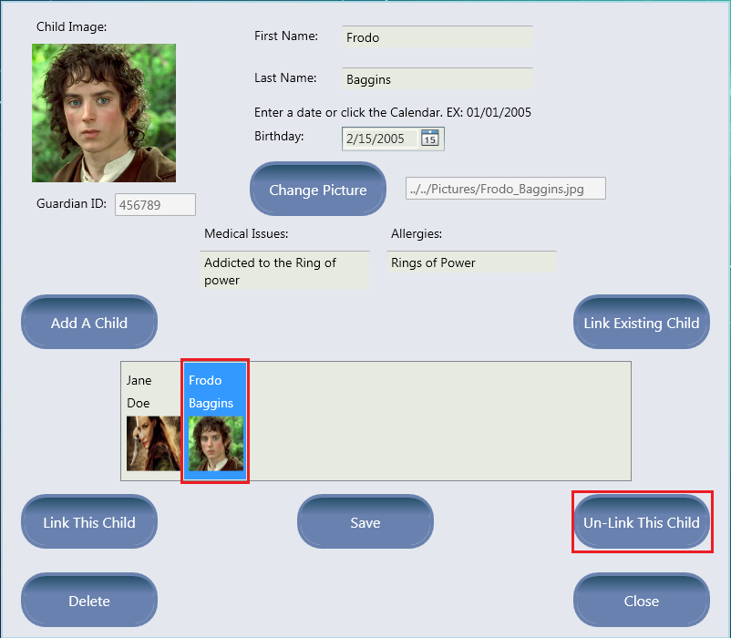
  2. Un-linking a child is very similar to linking a child (4.5.5). What Un-Linking a child does is is it removes a child from a specific guardian's list. That guardian will no longer be able to check the child in or out on the guardian side of the application. Also, this guardian ID can no longer be entered as a way to edit this child’s information.

The first step is to select the child from the child selection box. Once the child is selected you will want to click the “Un-Link this child button”. Note that a guardian can un-link a child from themselves, or a different guardian. Once you have clicked the button, you will see the same window to enter a guardian ID. Enter the guardian ID and click “Enter”. This will un-link the child from the guardian with the entered ID. 



### 4.5.7 Deleting a Child



If you need to delete a child from the database, the “Delete” button is your best and only option. This will delete the child from the database for every guardian. **This is a permanent action.** **There is no undo button for this.** Do not delete unless you have a need to. If you want to remove a child from a specific guardian see section 4.5.6on Un-Linking a child from a specific guardian. 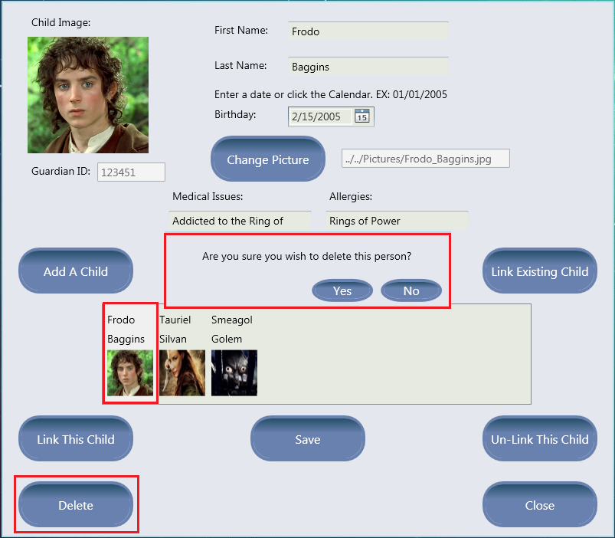



If you do decide that a child needs to be deleted, what you will do is select the child from the child selection box. From here, you will click the “Delete” button. This will give you a deletion confirmation window. If you click the “Yes” button, you will permanently delete this child. If you click “No” then the action will be canceled.

* 1. 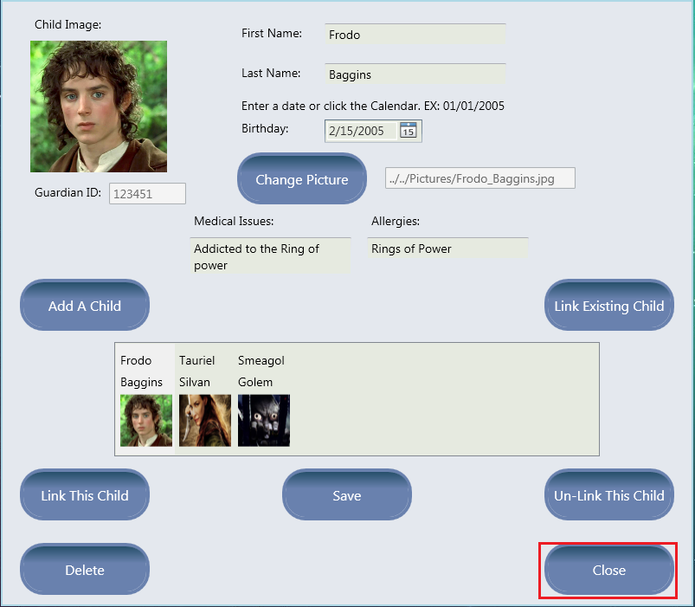

### 4.5.8 Closing the Window



Once you have finished everything you need to do in terms of editing a child, you will want to close the window. Do not forget to click the “Save” button if you have made any changes to a child's information. Any changes made from linking or un-linking children are saved automatically. To close the window, simply click the “Close” button. This will take you back to the Administrator Menu.

## 4.6 Adding and Editing Events

Events can be added or edited by clicking the “Edit / Add Events” button. Using this feature, you will be able to change the price of events, change how events are charged, change when events are offered, and create new events. Events can be charged at an hourly rate or at a flat rate for the day. Availability of events can be set to always available, available on a specific day of the week, or available on a specific day of the month. An optional discount rate can be set for events. The discount rate applies the discounted rate to additional children that are checked in under the same parent/guardian. It is also possible to set a maximum hour cap for each event. If a child is checked in for longer than the maximum hour cap, the late fee is charged for any additional time the child is checked in.

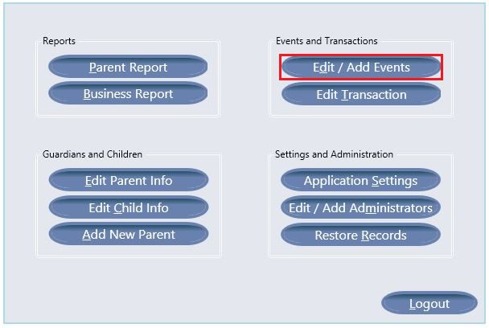

### 4.6.1 Protected Events

Some events are necessary for application operation and are protected:

* *Regular Events*
* *Adolescent Childcare*
* *Infant Childcare*
* *Late Fee*

are protected events. The names of these events may not be changed, and can not be changed from Always Available. The rates may, however, be changed. The Discount Rate and Maximum Hours cap can also be set for each of these with the exception of the Late Fee. The only changeable field for the Late Fee is the rate.

### 4.6.2 Event Categories

There are three event categories. The Regular Childcare category includes charges for Infant Childcare, Regular Childcare, and Adolescent Childcare. The Camp category includes any event with the word “camp” in it (Day Camp, Camp, Spanish Camp). The final category is the miscellaneous category which includes all other events. Totals are kept for these three event categories and are visible in the Parent Report window. Note that the totals are the sum of all charges for each family.

### 

### 4.6.3 Add Event

To add an event, click the “Add Event” button. This will bring up the Event Modification Window.

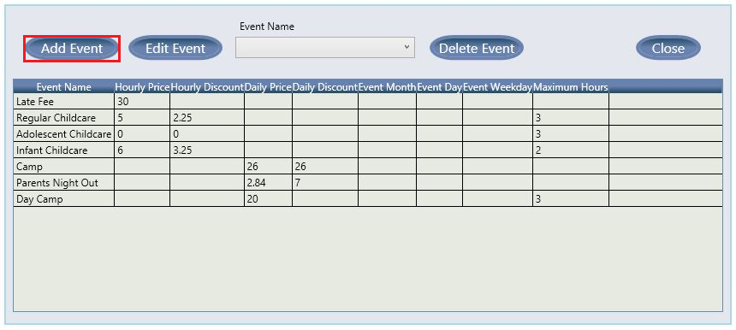

### 4.6.4 Edit Event

To edit an existing event, you can either click the event in the data grid or select an event name from the drop down box. After selecting an event, click the “Edit Event” button. This will bring up the Event Modification Window.

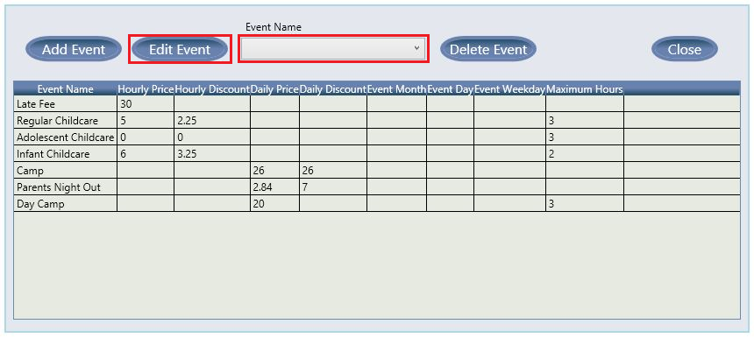

### 4.6.5 Delete Event

To delete an event, you can either click the event in the data grid or select an event name from the drop down box and then click the “Delete Event” button.

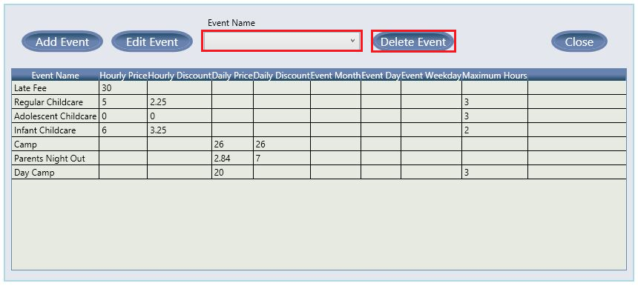

### 4.6.6 Event Modification Window

The Event Modification window has several required fields and some optional fields. The Event Name, Price Type, Rate, and Event Occurrence fields are required, while the Discount Rate and Maximum Hours fields are optional. Based on the selected Event Occurrence, additional required fields may appear. When you have finished entering the event data, click “Submit”.

### 

### 

### 4.6.6.1 Specific Day Events

If the Specific Day Event Occurrence is selected, two additional text boxes will appear. The Day of Month text box is for the day number (example: “12”). The Month Number text box is for the month number (for January you would enter “1”). Both text boxes are required information.

### 

### 4.6.6.2 Weekly Events

If the Weekly Event Occurrence is selected, an additional drop down box will appear. Select a day from the Day drop down box. The Day drop down box is a required field.

## 

## 4.7 Adding and Editing Transactions

Transactions can be added, deleted, or edited by clicking the “Edit Transaction” button. Transactions show the Guardian ID, Transaction ID, date, first and last name of the parent/guardian, the event name, and the charge amount for each transaction currently stored in the database. Modifying events will also update the appropriate event category balance for the associated family.

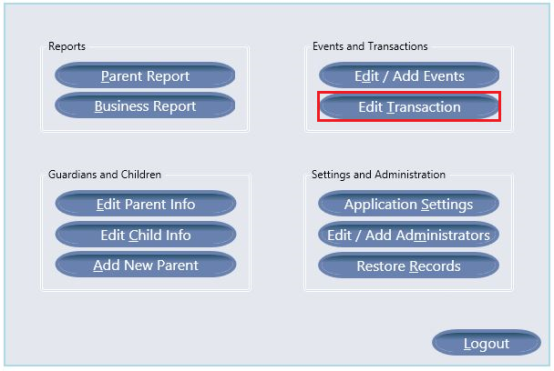

### 

### 

### 4.7.1 Editing Transactions

To edit a transaction you can either manually enter the Transaction ID, or click the transaction in the list to load the associated Transaction ID into the Transaction ID text box. After the Transaction ID is entered, click the “Edit Transaction” button to open the Event Modification window.

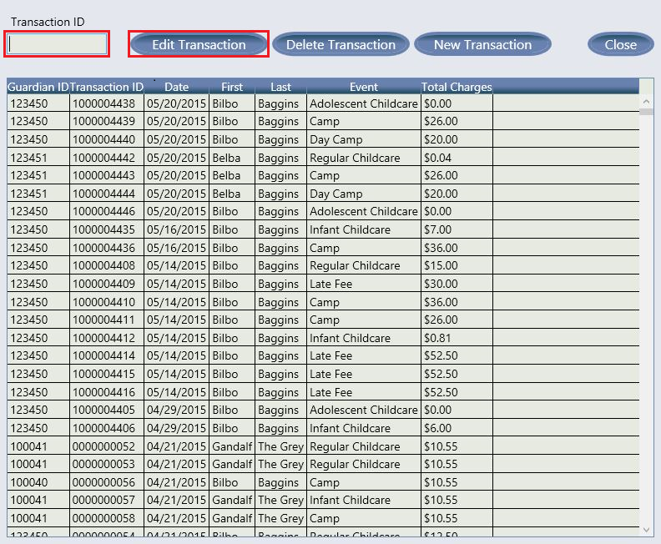

### 4.7.2 Deleting Transactions

To delete a transaction you can either manually enter the Transaction ID, or click the transaction in the list to load the associated Transaction ID into the Transaction ID text box. After the Transaction ID is entered, click the “Delete Transaction” button to delete the transaction.

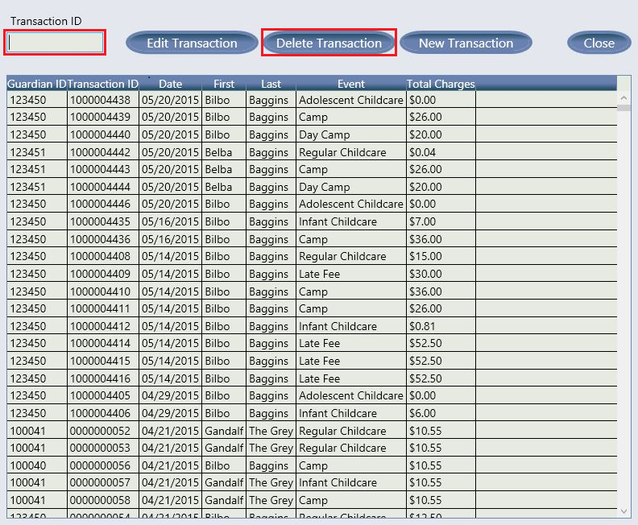

### 4.7.3 New Transactions

To create a new transaction, simply click the “New Transaction” button. This will open the Transaction Modification window where you can enter the transaction details.

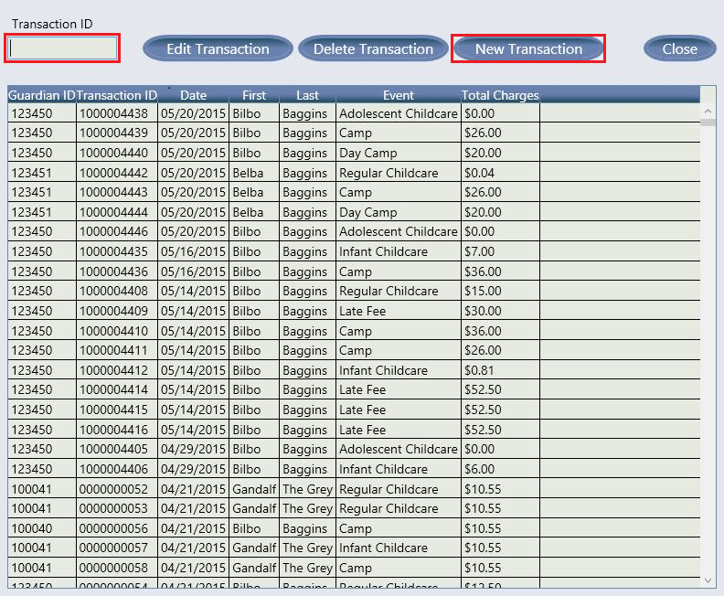

### 4.7.4 Transaction Modification Window

The Transaction Modification window allows you to edit or create transactions. All fields are mandatory and must fit the format specified in brackets below the text boxes. The Full Guardian Name is the first and last name of the parent/guardian this transaction will be charged to. The Full Child Name is the first and last name of the child associated with this transaction. Both names must be spelled correctly and the child and parent/guardian must be linked in the database for the transaction changes to be made. The event drop down box will populate with all events currently in the database. The Checked In and Checked Out text boxes refer to the times at which the child was checked in and out of the system. The Transaction Date text box is the date on which the event occurred. The Transaction Total is the total charge for the transaction. Note that when you change the event or the checked in/out times the Transaction Total will be filled with the appropriate charge for the time the child was check in and the event time. You may still edit the total if you wish. If the time the child was checked in for would generate a Late Fee charge, this charge is created as a new transaction and added to the database when you click “Submit”. When you are finished creating or editing the transaction, click “Submit”, or click “Cancel” to cancel any modifications.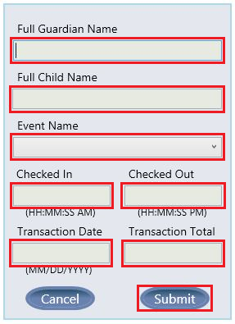

## 4.8 Checking Children In and Out

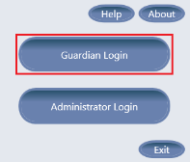

The child check-in system will be used by parents/guardians, to check children in and out of the childcare application. This system is also responsible for tracking childcare transactions in terms of date, check-in time, check-out time, and the final childcare charge. To access the child check-in system, simply click the “Guardian Login” button from the application’s startup menu.

### 4.8.1 Checking a Child In or Out as a Guardian

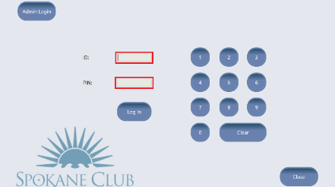

After clicking the “Guardian Login” button, the guardian login screen will be presented. This is likely the screen that will be the most desirable to leave open, while waiting for parents/guardians throughout business hours. In order to login, a guardian must enter their Spokane Club member number, and the pin chosen when they were registered with this application. They may use the keyboard or onscreen number pad, to enter their numbers into both fields. When both numbers are entered, the guardian may then click the “Log In” button to be taken to the child check-in screen.

On the child check-in screen, the guardian will first need to choose an event. If no “special events” are currently available, then “Regular Childcare” will automatically be selected. After an event is selected, the guardian must then select a child from the list of children that are currently eligible for check-in. Once a child is selected, the guardian may then click the “Check In” button. At this point the child will be checked into the system, and the check-in time will be recorded.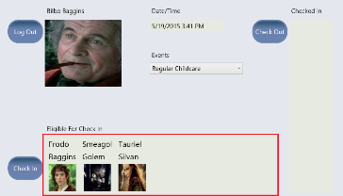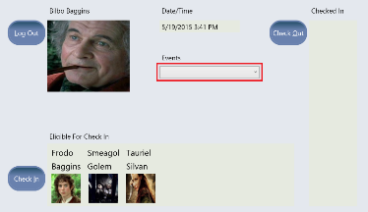

A child may also be checked out from this screen. To check out a child, the guardian must select a child from the list of children that are currently checked in. After selecting a child, the guardian may then click the “Check Out” button. At this point the check-out time will be recorded and the childcare fee will be calculated based on the event chosen and the amount of time the child was checked in. The total fee will be charged to the guardian’s current balance. Any late fees that are applicable will also be calculated and charged to the guardian’s balance at this time. At this point the child will be successfully checked out of the system and the guardian can choose to check in or out another child or click the “Log Out” button. When the “Log Out” button is clicked, the child check-in screen will close and the guardian login screen will be presented and ready for the next guardian.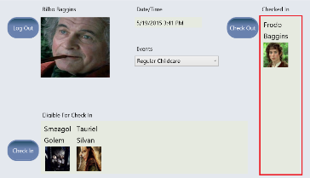

### 

### 4.8.2 Checking a Child In or Out as an Administrator

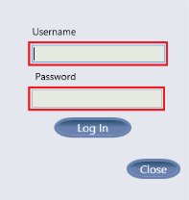

From the guardian login screen (shown in section 4.8.1), an administrator may choose to click the “Admin Login” button. The administrator login window will be presented. The administrator may then log in by typing their username and password into the input fields and clicking the “Log In” button.

The administrator will then be presented with a window that will allow them to search for a guardian by last name or by member number. Should the administrator choose to type a last name into the input field, they will be presented with a list of matching guardians. The administrator may then select a desired guardian and click the “Login As Selected Guardian” button. Alternatively, should the administrator choose to type a member number into the input field and then click search, they will immediately be logged in as the matching guardian (provided a match is found). 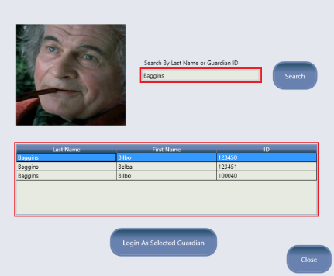

The administrator will then be presented with the child check-in screen (shown in section 4.8.1). From this point forward, the child check-in process is exactly as detailed in section 4.8.1. After checking the desired children in or out, the administrator may then click the “Log Out” button, to be returned to the guardian login screen.

# 

# 5.0 Backup and Restore

## 5.1 Automatic Backup System and Restore Points

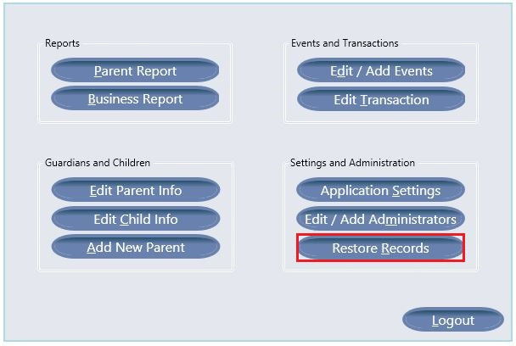

This application includes a system that will automatically backup the database, which contains all of the records generated by this software. The database will be backed up once per week, and all backups will be saved for ten weeks. At any point, should an administrator wish to restore all records to a previous backup, they may do so using the Restore Records system. To use this system, an administrator must first login. Once logged in, the administrator may click the “Restore Records” button from the administrator menu. The administrator will then be presented with the restore window. From this window, the administrator may click the “Select Restore File” button. This will open a browser window allowing the administrator to choose any of the ten most recent backup files. After choosing a backup file, the administrator can see their chosen file from the restore window. At this point, the administrator may click the “Restore” button to complete the process. This process is not reversible, and will result in the loss of all records between the date of the backup point and the current date. The restore process should only be used if the database has malfunctioned in a way that causes it to be inoperable.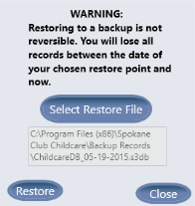

## 

## 

## 5.2 Complete Re-Installation

Should it ever become necessary to re-install this application, it is possible to do so without the loss of records. To do this an administrator must first save the required files manually. To begin, browse to the application's installation directory. By default, the installation directory is: C:\Program Files (x86)\Spokane Club Childcare. Within the install directory, several folders will be visible. Copy the “Database” folder to a safe location, where it will not be modified or deleted. Next, browse to where pictures and reports are stored; by default this location is C:\Users\Public\Documents\Childcare Application. Copy both the “Pictures” folder and the “Saved Reports” folder to a safe location. Now it is safe to uninstall the application. The application can then be re-installed, by following the directions in section 3.1 of this manual. After installation, browse once again to both of the above listed directories. Delete the existing “Database”, “Pictures”, and “Saved Reports” folders, then replace them with the “Database”, “Pictures”, and “Saved Reports” folders that were previously saved to a safe location. The application is now ready to use with all records intact.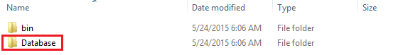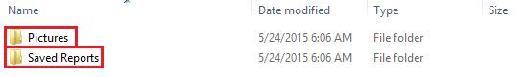

# 

# 

# 6.0 Troubleshooting

## 6.0 Troubleshooting

## 6.1 What to do if Something Goes Wrong

This application is self maintaining, and we at Eastern Washington University have worked hard to insure that the chances that something will go wrong are as minimal as possible. However, should something occur that causes this application to behave in a way other than intended, here are a few possible solutions. The first and easiest solution to try, is simply close the application, restart your computer, then open the application again. This will hopefully solve most potential problems. The second possibility to consider, is restoring the database to a previous backup point as described in section 5.1 of this user manual. This option may be useful if the application is displaying consistent error messages warning that the database may be inaccessible or missing. The last and most drastic solution should the application become inoperable, is to perform a complete re-installation, as described in section 5.2 of this user manual.

## 6.2 In Case of Complete Application Failure

!*! DISCLAIMER: This application is provided “as-is” with no promise of patches or support from the developers in case of errors. With that understanding, if the application reaches a state where none of the solutions in 6.1 are able to restore functionality then there is one final option that may help.

The application under which this software was developed at Eastern Washington University is overseen by Tom Capaul who can be reached at: [tcapaul@ewu.edu](mailto:tcapaul@ewu.edu)

Further development of the application by EWU students may be possible under certain circumstances, or you may be put in touch with developers.